B.Tech CSE (III YEAR – V SEM) (2026-27)
DEPARTMENT OF COMPUTER SCIENCE ENGINEERING & APPLICATIONS


GLA UNIVERSITY
17km Stone, NH-2, Mathura-Delhi Road, P.O. Chaumuhan, Mathura – 281406
(Uttar Pradesh) India

Project Title: CEO-IN-A-BOX: An Autonomous Enterprise Decision-Making Agent

Team Leader: Prakhar Kulshreshtha UR: 2415500343
Team Member 1: Ananya Awasthi UR: 2415500067
Team Member 2: Palak Singh UR: 2415500326
Mentor Name: Govind Gupta
Signature :

Project Title:
CEO-IN-A-BOX: An Autonomous Enterprise Decision-Making Agent
Cover
- Project title: CEO-In-A-Box-An Autonomous Enterprise Decision-Making Agent
- Team name & ID: (T-140)
- Institute / Course: GLA University, Mini-Project

● Version: v1.0
● Date: 25th Aug 2026

1. Overview
- Problem statement: Modern enterprises generate large volumes of market, financial, and operational data at a pace that exceeds human capacity for timely analysis. Existing decision-support dashboards present data but do not reason over it, and they rarely provide a transparent, explainable rationale for the actions they imply. Decision-makers are thus left to manually synthesize inputs from multiple domains under time pressure, with no mechanism to audit or trace why a particular choice was made
- Goal:Build an autonomous multi-agent AI system — AutoCEO — that simulates enterprise decision-making by coordinating five specialized agents. The system analyzes multi-domain signals, produces a final business decision, explains its reasoning at every step.
- Non-goals: Real financial transaction execution, connection to live enterprise ERP systems, or institutional-grade quantitative modeling are explicitly out of scope in v1.
- Value proposition: A transparent, end-to-end explainable decision pipeline — every agent’s reasoning is logged, structured, and displayable — making this demonstrably different from a black-box chatbot and directly addressing the core limitation of existing decision-support tools.

2. Scope and Control

In-scope

Five-agent orchestration pipeline
- Structured JSON output validation at each agent boundary
- Decision logging and explainability audit trail
- Web-based scenario input dashboard and live decision display
- Deployment as a live public web app

2.2 Out-of-scope
- Live financial transaction execution
- Real-time ERP integration
- mobile apps,
- advanced portfolio optimization in v1.

2.3 Assumptions
- Users have basic familiarity with business concepts
- Gemini API free tier remains available at current quota levels throughout development
- Synthetic data scenarios are sufficient for demonstrating and evaluating reasoning quality

2.4 Constraints
- All decisions must be explainable
- API usage limits
- Academic project timeline

2.5 Dependencies

Gemini API (Google AI Studio) — primary LLM provider
- yfinance / Alpha Vantage — optional real market data feeds
- Cloud infrastructure for AI processing

2.6 Acceptance criteria and sign-off
- GIVEN a business scenario CSV WHEN the pipeline runs THEN all five agents produce valid structured JSON and the Executive agent outputs a decision with written rationale within 30 seconds
- GIVEN a crisis event is injected WHEN the pipeline re-runs THEN the Executive decision changes and the change is logged with an explanation
- GIVEN the decision log WHEN the explainability dashboard is opened THEN every agent’s input, output, and reasoning trace is visible and queryable

Sign-off table
Stakeholder | Role | Decision area | Signature/Approval | Date
Mr. Govind Gupta | Mentor | Scope, final acceptance | Approved | 04/09/2026
Prakhar Kulshreshtha | Product Lead | Release readiness | Approved

3. Stakeholders and RACI
Activity | Responsible (R) | Accountable (A) | Consulted (C) | Informed (I)
Requirements | Ananya Awasthi | Prakhar Kulshreshtha | Mentor | Team
Design | Palak Singh | Prakhar Kulshreshtha | Mentor | Team
Implementation | Prakhar Kulshreshtha | Prakhar Kulshreshtha | — | Team
Testing | Prakhar Kulshreshtha | Prakhar Kulshreshtha | Mentor | Team
Release | Prakhar Kulshreshtha | Prakhar Kulshreshtha | Mentor | Dept

4. Team and Roles
Member | Role | Responsibilities | Key skills | Availability | Contact
Prakhar Kulshreshtha | Product Lead | Scope, backlog, reviews | Product, APIs | 8 hrs/wk | prakhar.kulshreshtha_cs.aiml24@gla.ac.in
Prakhar Kulshreshtha &  Ananya Awasthi | Tech  Lead &  Backend | Arch, APIs, security | Node,  Express,  SQL,WebSo  ckets | 10 hrs/wk | Ananya.awasthi_cs.aiml24@gla.ac.in
Palak Singh & Ananya Awasthi | Frontend | React UI, state, a11y | React, TS | 10 hrs/wk | Palak.singh_cs.aiml24@gla.ac.in
Prakhar Kulshreshtha | QA &  Docs | Test plan, E2E, docs | Playwright, writing | 8 hrs/wk | Prakhar.kulshreshtha_cs.aiml@gla.ac.in

5. Week-wise Plan and Assignments
(Example schedule for Sep–Oct 2025; adjust to your calendar.)
Wee  k | Date  s | Milestones | Akshya( Lead) | Akshya( Backend) | Manish(F rontend) | Divya(QA/ Docs) | Deliverable  s | Status
1 | 8-14  Aug | Requiremen  ts freeze | Finalize scope | API contracts v0 | Wirefram  es | Test plan v0 | Draft SRS | Planned
2 | 15-24  Aug | Architectur e & DB | Arch review | Schema & migration  s | UI kit | Test data | ERD, API spec v1 | Planned
3 | 25-31  Aug | Backend scaffolding | Risks, unblock | Auth +  Users  API | Auth screens | Smoke  tests | Auth module | Planned
4 | 2- 10  Sep | Frontend scaffolding | Sync | Listings  API | Routing, forms | Accessibili ty checks | UI shells | Planned
5 | 11-17  Sep | Feature set  A | Cut scope | Create/Ed  it listing  E2E | Listing pages | CRUD  tests | Feature A demo | Planned
6 | 18-23  Sep | Feature set  B | KPIs | Search API | Search UI + Profile | Perf tests | Feature B demo | Planned
7 | 13-20  Oct | Hardening | Risk burndown | Bug fixes | Bug fixes | Regression suite | Test report | Planned
8 | 24 Oct-2Nov | Release & deck | Final sign-off | Release notes | Polish UI | User manual | v1.0, slides | Planned

6. Users and UX

6.1 Personas
- Business Student / Evaluator: Needs to see a clear, readable decision with an explanation they can follow and question during a viva
- System Tester: Wants to inject different scenario data and verify that agent outputs and the final decision change appropriately

6.2 Top User Journeys

User opens dashboard → selects or uploads a business scenario (market/finance/HR data) → clicks ‘Run’ → watches five agents run sequentially → reads the Executive Agent’s final decision with rationale → views the full decision log for explainability → optionally injects a crisis and re-runs to see adaptive re-planning

6.3 User Stories

As an evaluator, I want to see each agent’s reasoning step so that I can verify the system is not a black box.

6.4 Accessibility & Localization
- Simple language explanations

- Mobile-friendly interface

- English language support

7. Market and Competitors

7.1 Competitor table

Competitor | Product | Target users | Key features | Pricing | Strengths | Weaknesses | Our differentiator
AutoGen (Microsoft) |  | Researchers, developers | Multi-agent conversations, debate-style reasoning | Freemi um  (Pro:  $14.95/ mo) | Professio nal-grade tools,  50M+ users, real-time data, strong  communit  y | No explicit decision hierarchy; agents debate freely, hard to control output structur | Fixed hierarchy: 4 specialists report to 1 executive; structured JSON at every step
CrewAI |  | developers | Role-based agents, quick to prototype | Freemi um (Premiu m: $239/yr  ) | Expert opinions,  comprehe  nsive data, dividend focus | Framework controls flow, hard to explain or audit exact routing logic in a viva | LangGraph: explicit graph = every routing decision is visible and explainable
ChatGPT / Gemini (vanilla) |  | General Users | Conversational AI, broad knowledge | Free (Gold:  $5/mo) | Easy execution, gamified UX, popular with young users | No persistent state, no structured multi-agent pipeline, no decision logging | Persistent decision log, Pydantic-validated outputs, full audit trail

7.2 Positioning
AutoCEO’s differentiator is the combination of structured multi-agent hierarchy + enforced schema validation + complete explainability logging. Each of these exists in isolation in other tools, but no free-tier student-accessible system combines all three in a single end-to-end pipeline.

8. Objectives and Success Metrics
- O1: Pipeline completeness — all 5 agents run end-to-end on a scenario and produce valid JSON — by Week 6
- O2: Explainability — 100% of decisions have a logged, queryable reasoning trace — by Week 7

- O3 Adaptability — system produces a measurably different decision when crisis data is injected — by Week 8
- O4: Deployment — live public URL accessible without local setup

9. Key Features
Feature | Description | Priority | Dependencies | Acceptance criteria
Market Intelligence Agent | Reads market/sector data, identifies top trend, outputs demand direction and confidence score as JSON | Must | SMTP | GIVEN market CSV WHEN agent runs THEN returns valid JSON with trend_summary, demand_direction, confidence, recommendation within 10s
Finance Agent | Assesses financial health from budget/revenue data, recommends safe spend range | Must | Auth, Storage | GIVEN finance CSV + market summary WHEN agent runs THEN returns financial_health, safe_budget_range, and budget_flags
Operations Agen | Evaluates team capacity and staffing from HR roster, recommends hire/fire/reassig | Must | Listings | GIVEN HR CSV WHEN agent runs THEN returns capacity_status, staffing_recommendation, operational_risk
Risk & Compliance Agent | Flags any recommendation that violates predefined compliance rules or introduces unacceptable risk | Must | Auth | GIVEN all prior outputs WHEN compliance rules are applied THEN returns risk_level and any violations
Executive Reasoning Agent | Synthesizes all four agent outputs into a single decision with written rationale and re-evaluation trigge | Must | Auth | GIVEN all 4 agent outputs WHEN executive runs THEN returns decision, rationale, key_influences, risk_accepted, reevaluation_trigger

10. Architecture

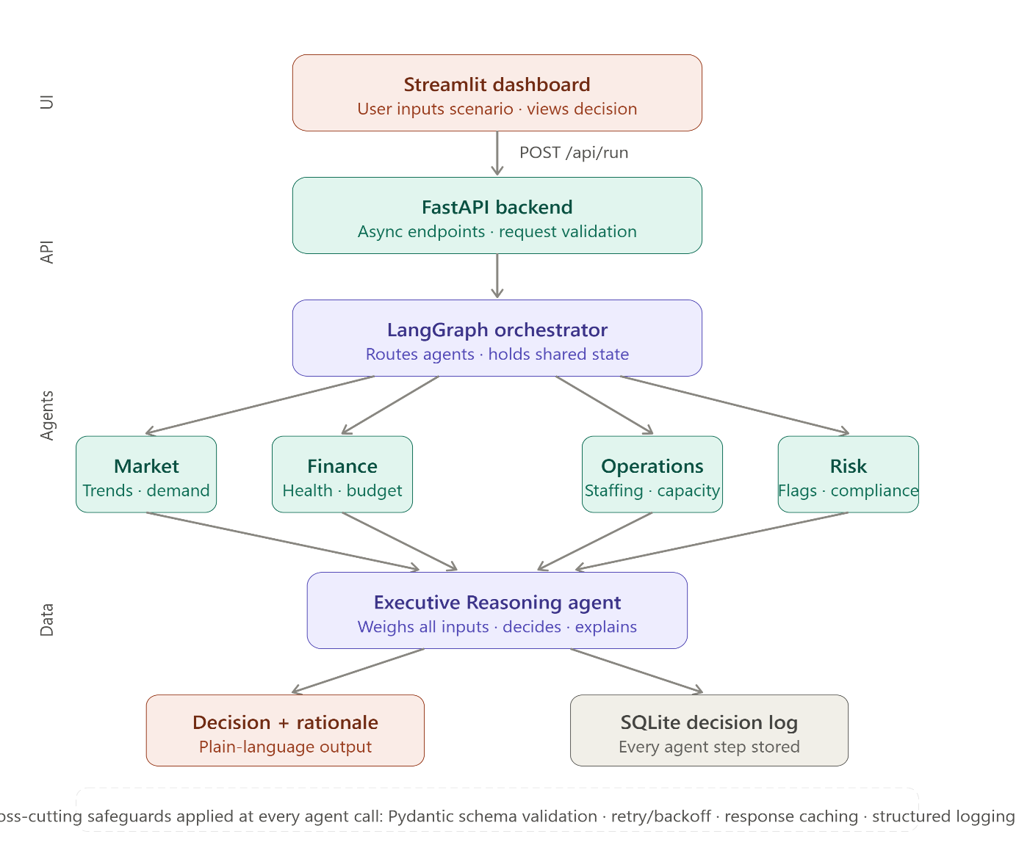

10.1 High-Level Architecture
The system follows a modular and scalable architecture designed to support realtime data processing and personalized AI-driven advisory.
- Clients:
Web-based Single Page Application (SPA) developed using React. The client provides dashboards, charts, and a conversational interface for user interaction.

- Backend Services:

  - Authentication Service: Handles user registration, login, and secure access.

○ Profile Service: Manages user risk profiles, investment goals, and preferences.

○ Market Analysis Service: Fetches and processes real-time and historical market data.

○ Recommendation Engine: Generates personalized buy/hold/sell suggestions using AI models.

- Data Stores:

  - MySQL Database: Stores user data, investment profiles, portfolios, and logs.

○ Object Storage: Stores charts, reports, and backtesting results if required.

- Integrations:

  - Market Data APIs (Yahoo Finance / Alpha Vantage)

○ LLM Provider (OpenAI / Groq)

○ SMTP service for alerts and notifications

10.2 API spec snapshot
Endpoint | Method | Auth | Purpose | Request schema | Response schema | Codes
/api/auth/register | POST | — | Create account | Run full 5-agent pipeline on scenario data | 201 {id} | 201, 400
/api/profile/create | POST | JWT | Create investment profile | riskLevel, goals | 201  {listingId} | 201, 400,  401
/api/market/analyz e | GET | - | Analyze stock | Fetch full decision log for a past run | 200 {items[], total} | 200

10.3 Configuration and Secrets
- All API keys stored in .env file — never hardcoded in source
- .env added to .gitignore before first commit — verified before pushing to GitHub
- Gemini API key rotated if accidentally exposed

11. Data Design

11.1 Core Entities
- Scenario
- AgentCall
- DecisionRun
- ComplianceRule
User data is securely stored with encryption and strict access control.
User data is securely stored with encryption and access control.

11.1 Data dictionary
Entity | Field | Type | Null? | Allowed values | Source | Notes
Decision  Run | run_id | UUID | No | — | System | PK
Decision  Run | scenario_id | String | No |  | User | Unique
Decision  Run | final_decision | Enum | No | Low/Medium  /High | User | PK
AgentCall | call_id | UUID | No |  | Market API | Indexed
AgentCall | Run_id | UUID | No | ≥ 0 | System | —

11.2 Schemas and Migrations
- ER Diagram included in appendix

- Database migrations version-controlled

- Rollback tested on staging environment

11.3 Privacy, Retention, Backup, and DR
- Personally Identifiable Information (PII): name, email

- Retention policy: delete inactive accounts after 12 months

- Nightly automated backups

- RTO: 4 hours

- RPO: 24 hours

12. Technical Workflow Diagrams
The following diagrams are included to explain system behavior:
- State Transition Diagram

- Sequence Diagram

- Use Case Diagram

- Data Flow Diagram (DFD)

- Entity Relationship Diagram (ERD)

- System Architecture Diagram

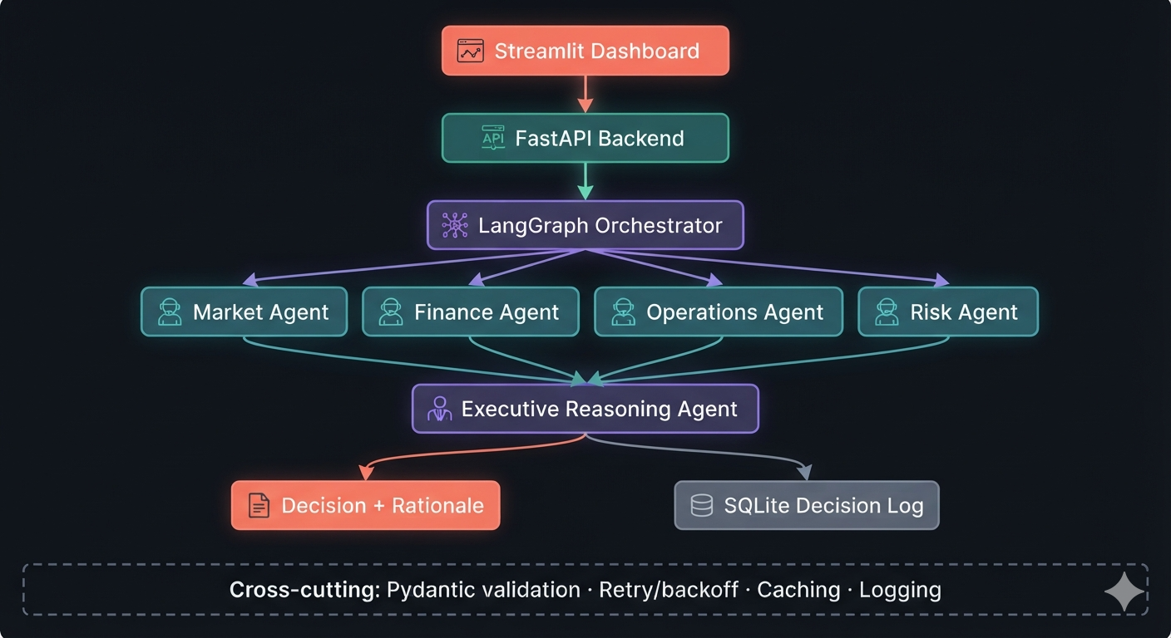

13. Quality: NFRs and Testing

13.1 Non-functional requirements
Metric SLI | Target (SLO) | Measurement
Availability Uptime % | ≥ 99.0% | Uptime monitor
Latency p95 | ≤ 1000 ms | APM
Error rate 5xx % | ≤ 1% | Logs
Security Critical CVEs | 0 | Vulnerability
scanner

13.2 Test plan
Area | Type | Tools | Owner | Coverage target | Exit criteria
Backend | Unit | Jest | Prakhar | 70% | No P1/P2 defects
UI | E2E | Playwright | Ananya | 60% | Pass rate ≥ 95%
API | Integration | Postmann | Palak | All Scenarios | All critical pass

13.3 Environments
- Development → Staging → Production

- Feature flags used for experimental features

14. Security and Compliance

14.1 Threat model (STRIDE)
Asset | Threat | STRIDE | Impact | Likelihood | Mitigation | Owner
Auth tokens | Theft | Spoofing | High | Medium | HTTPS, short TTL, rotation | Rohit
User data | SQLi | Tampering | High | Low | Parameterized queries,  WAF | Rohit

14.2 AuthN/AuthZ
- Email + password authentication

- JWT-based authorization

- Role-based access control

14.3 Audit and logging
- Log signups, logins, listing CRUD, reports; 90-day retention.

14.4 Compliance
● Academic project; follow institute policy; no third-party data sharing.

15. Delivery and Operations

15.1 Release plan
- Version v1.0 demo at project submission
- Incremental feature rollout

15.2 CI/CD and rollback
- CI pipeline: lint → test → build → deploy
- Rollback using previous container image

15.3 Monitoring and alerting
Metric | Threshold | Alert to | Runbook
p95 latency | > 1200 ms | Tech Lead | “API Latency” runbook
Error rate | > 2% | Tech Lead | “Error Spike” runbook

15.4 Runbooks
- API Latency: check DB indexes → scale pods → revert change.
- Error Spike: inspect logs → roll back → create incident note.

15.5 Communication plan
● Standups Mon/Wed/Fri. Weekly status to mentor each Friday. Bi-weekly demo.

16. Risks and Mitigations

16.1 Risk heatmap
Risk | Probability | Impact | Score | Mitigation | Owner | Status
Gemini API free-tier quota exhausted during crunch | Medium | High | 12 | Implement response caching; use Groq as backup LLM | Prakhar Kulshreshtha | Open
Schedule slip due to LangGraph learning curve | Medium | Medium | 9 | Build plain-Python pipeline first (Week 1–2), migrate to LangGraph | Prakhar Kulshreshtha | Open
Prompt quality insufficient for coherent decisions | Low | Medium | 6 | Hand-test all prompts in AI Studio before coding; iterate until JSON is consistent | Prakhar Kulshreshtha | Open

17. Research and Evaluation

● 17.1 Study of Existing Platforms
Existing multi-agent frameworks (AutoGen, CrewAI, vanilla LangChain agents) were evaluated against three criteria: explainability of routing, suitability for a fixed decision hierarchy, and free-tier accessibility. LangGraph was selected because it is the only framework that models the pipeline as an explicit, inspectable graph rather than hiding routing behind framework abstractions — a critical requirement for a project where viva evaluators will ask exactly how data flows between agents..

● 17.2 Evaluation Using Historical Data
AutoCEO will be evaluated against 5–10 hand-crafted synthetic business scenarios covering: normal operations (baseline), demand contraction (market shock), budget overrun (finance shock), team under-capacity (operational shock), and compliance violation (risk shock). For each scenario, the Executive agent’s decision is manually reviewed for coherence, risk balance, and alignment with the injected conditions.

● 17.3 User Feedback
Peer review from classmates and faculty mentor will be used to assess clarity of the decision explanations and usability of the dashboard

● 17.4 KPI Tracking
Key metrics include response time (p95), recommendation accuracy, user engagement, and system uptime. Regular monitoring ensures reliability and continuous improvement.

18. Appendices

18.1 Glossary
- AI: Systems simulating human intelligence.
- FastAPI: A modern Python web framework for building
- Pydantic: A Python library for data validation

18.2 References

- LangGraph documentation: https://langchain-ai.github.io/langgraph/
- Google AI Studio (Gemini API): https://aistudio.google.com
- FastAPI documentation: https://fastapi.tiangolo.com
- Streamlit documentation: https://docs.streamlit.io
- Pydantic documentation: https://docs.pydantic.dev
- yfinance library: https://github.com/ranaroussi/yfinance
- IEEE: “Multi-Agent Systems for Decision Support” – https://ieeexplore.ieee.org

